PROJECT REPORT
AI-BASED TIMETABLE GENERATION SYSTEM
PROJECT DOCUMENTATION

TEAM MEMBER | ROLL NUMBER
THOTA JESHWANTH | 2603A52L14
JANAKURI SHASHANK | 2503A52947
Academic Project

Abstract
This project examines an AI-based timetable decision-support workflow using a supplied dataset of 1,000 timetable records and 25 attributes. The package includes Python programs for data cleaning, analysis and visualization, summary CSV files, eight chart images and a Power BI dashboard file. The analysis identifies 445 records as Valid and 555 as Needs Rescheduling. It also summarizes department distribution, conflict indicators, student strength and suggested actions. The results show how structured data processing can support timetable review and provide a foundation for a future automated scheduling and optimization application.

1. Introduction
Timetable scheduling is a constraint-heavy task because each class must be assigned a suitable day, time, faculty member and room while respecting availability, capacity and preference requirements. This project uses a structured timetable dataset and Python-based analysis to identify records that are valid and those that may require rescheduling.

2. Project Objectives
- Clean and prepare timetable records for analysis.
- Review timetable status and conflict indicators.
- Summarize records by department and recommendation.
- Study student-count and room-capacity information.
- Present findings through visualizations and dashboard-ready outputs.

3. Dataset Description
The Excel source file contains 1,000 records and 25 columns. Fields include Record_ID, Department, Semester, Section, Subject, Faculty_Name, Room_Number, Room_Type, Room_Capacity, Day, Start_Time, End_Time, Subject_Type, Student_Count, Faculty_Availability, Room_Availability, Faculty_Conflict, Room_Conflict, Capacity_OK, Preferred_Period, Preference_Match, Conflict_Flag, Priority, Timetable_Status and AI_Recommendation.
Dataset property | Observed value
Records | 1,000
Columns | 25
Duplicate rows after cleaning | 0
Missing cells after cleaning | 0
Departments | ECE, AIML, EEE, CSE, MECH
Days represented in visualizations | Monday to Saturday

4. System Workflow
- Read the Excel dataset using pandas.
- Clean column names and text fields by removing leading and trailing spaces.
- Convert blank strings to missing values and remove duplicate rows and duplicate record IDs.
- Fill missing numeric fields with their median and missing text fields with their mode (or Unknown).
- Save the cleaned records to clean_dataset.csv.
- Analyze department, status, recommendation, conflict and student-count information.
- Create visualizations and save them as PNG files for reporting.
- Use the cleaned dataset and summaries for dashboard reporting in the included Power BI file.

5. Implementation Details

5.1 Data Cleaning
The data_cleaning.py script reads the Excel file, strips spaces from column names and text values, replaces blank text with missing values, removes duplicate rows and duplicate Record_ID values, fills numeric missing values with medians, fills text missing values with the most frequent value (or 'Unknown' when no mode exists), and exports clean_dataset.csv.

5.2 Data Analysis
The Data_analysis.py script reads the cleaned CSV and calculates record count, column count, duplicate count, missing-cell count, department distribution, timetable status, AI recommendation distribution, conflict summaries and descriptive statistics for Student_Count. It writes analysis_summary.txt and three summary CSV files.

5.3 Data Visualization
The Data_visualisation.py script uses pandas and Matplotlib to generate eight charts: timetable status pie chart, AI recommendation donut chart, records-by-day line graph, student-count histogram, student-count-by-department box plot, student-count-versus-room-capacity scatter plot, department-wise status stacked bar chart and department-by-day heatmap.

6. Results and Analysis
The analysis output reports the following overall results:
Metric | Result
Total timetable records | 1,000
Total columns | 25
Duplicate rows | 0
Missing cells | 0
Valid records | 445 (44.5%)
Needs rescheduling | 555 (55.5%)
Faculty conflicts | 50 (5.0%)
Room conflicts | 72 (7.2%)

6.1 Department-wise Records
Department | Records
ECE | 217
AIML | 211
EEE | 195
CSE | 192
MECH | 185

6.2 AI Recommendation Categories
Recommendation | Records
Keep Slot | 445
Change Room | 148
Split Section | 140
Choose Another Time Slot | 135
Change Faculty | 132

6.3 Student Count Statistics
Statistic | Value
Mean | 44.86
Standard deviation | 12.09
Minimum | 25
25th percentile | 34
Median | 45
75th percentile | 56
Maximum | 65
The dataset shows that more than half of the records are marked for rescheduling. Room conflicts occur more often than faculty conflicts in the supplied labels. The student-count range is 25 to 65, so room capacity is an important scheduling factor to examine. These figures describe the supplied dataset and should not be interpreted as measured performance of a deployed AI model.

7. Visualizations
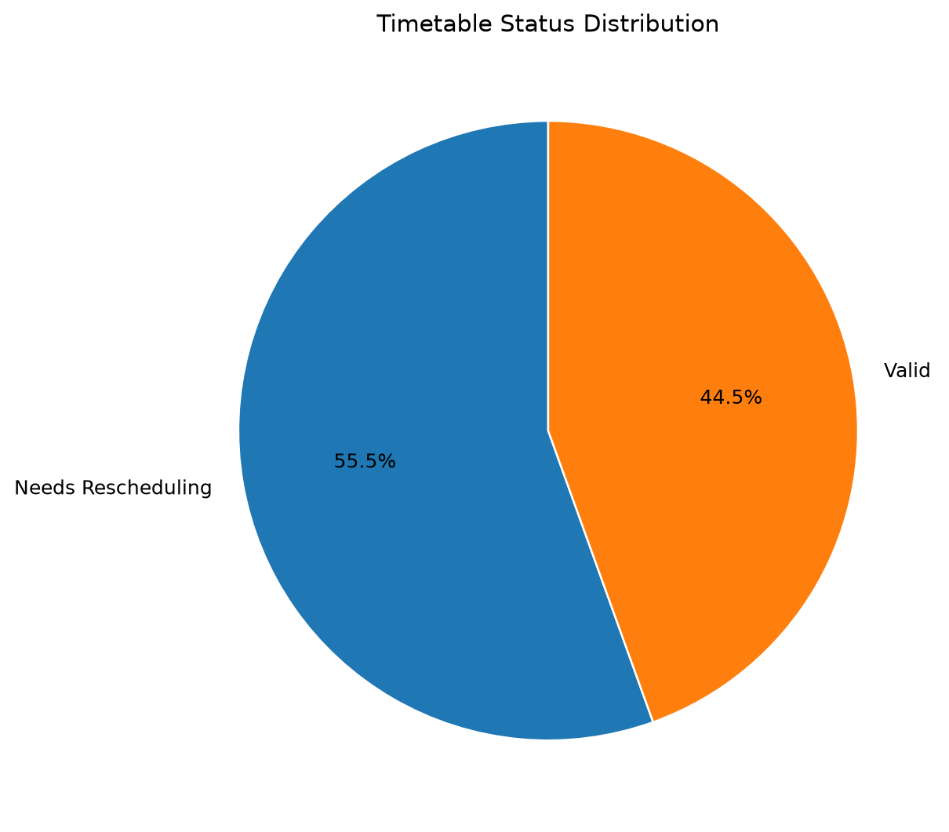
Figure 1. Timetable status distribution.
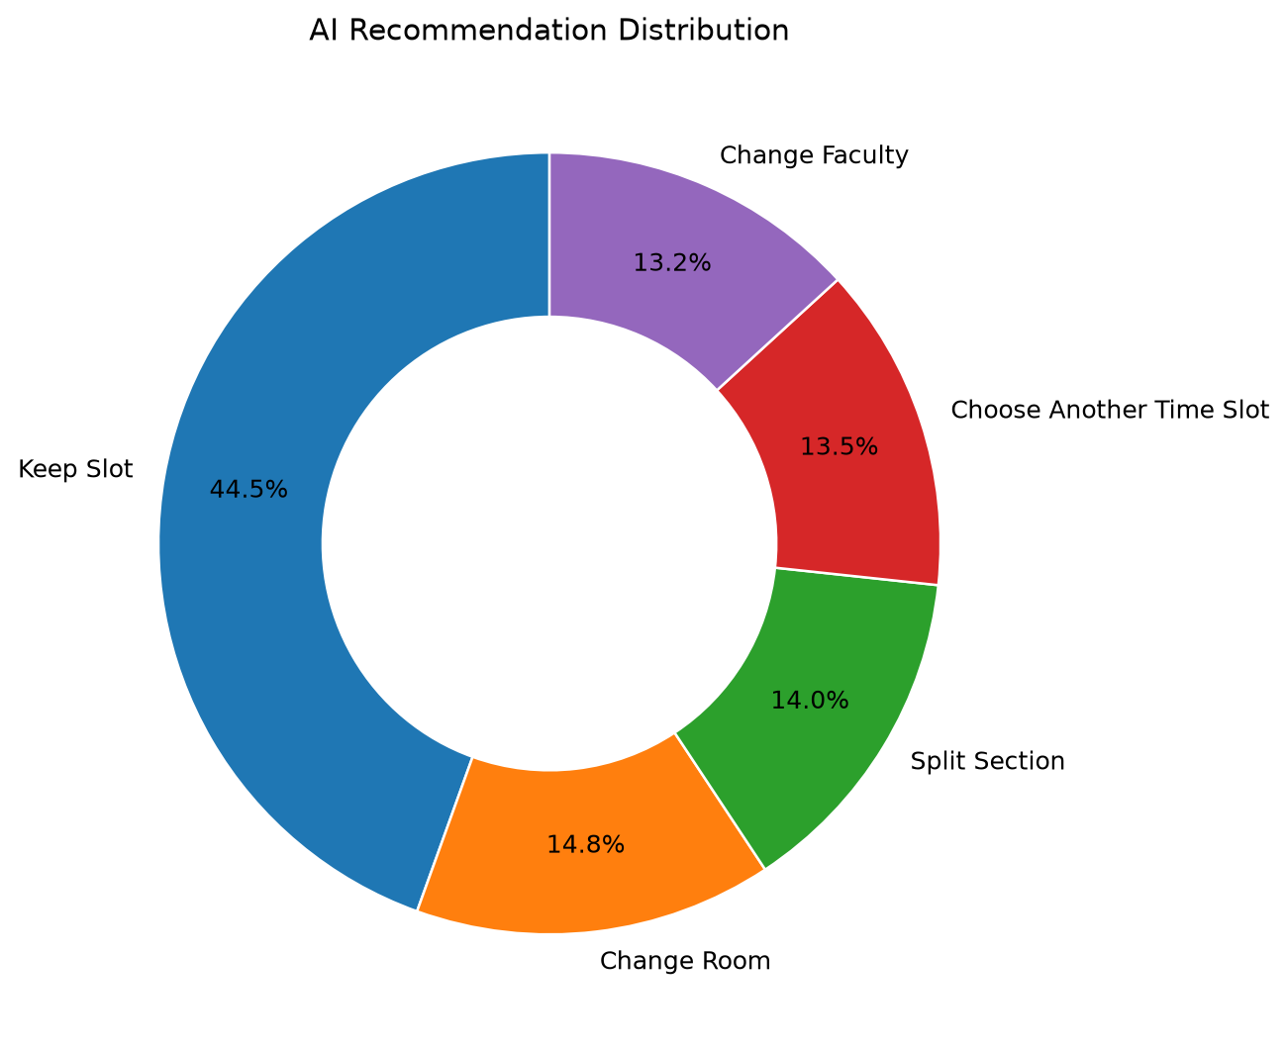
Figure 2. Distribution of recommendation categories.
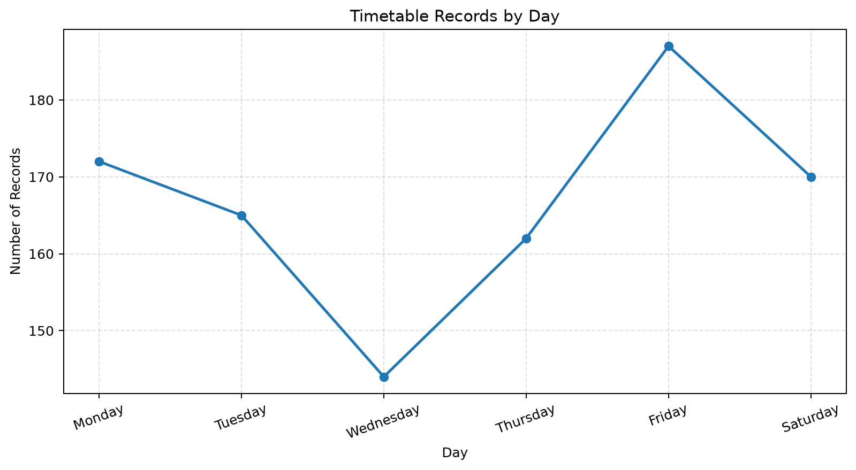
Figure 3. Number of timetable records by day.
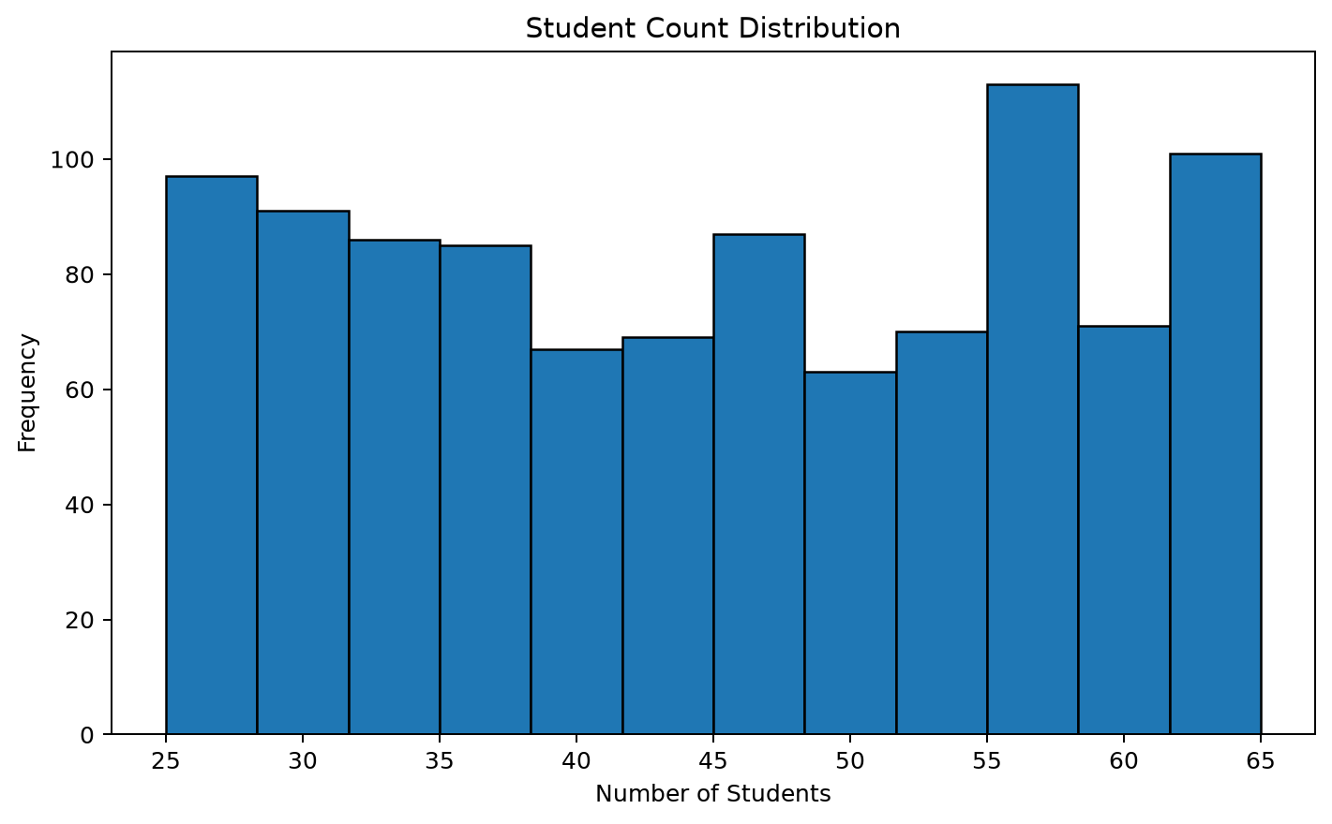
Figure 4. Distribution of student counts.
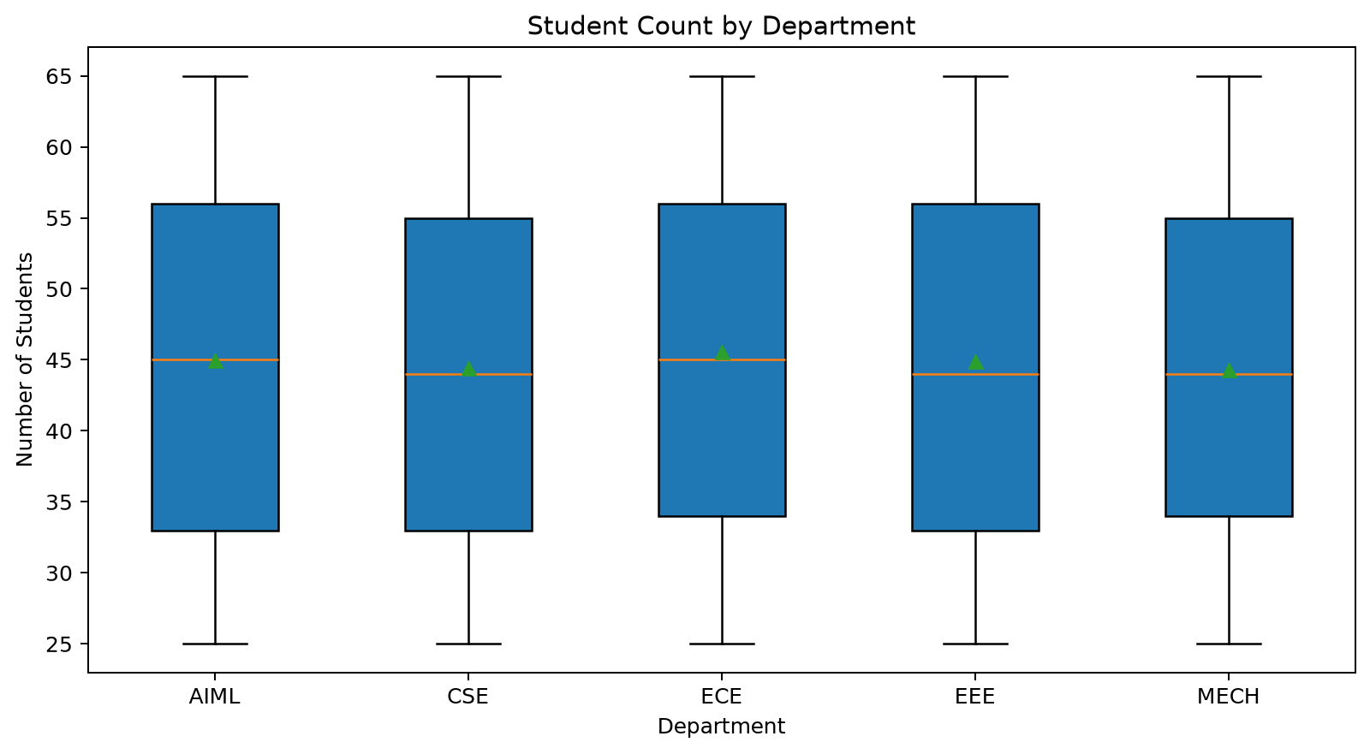
Figure 5. Student count by department.
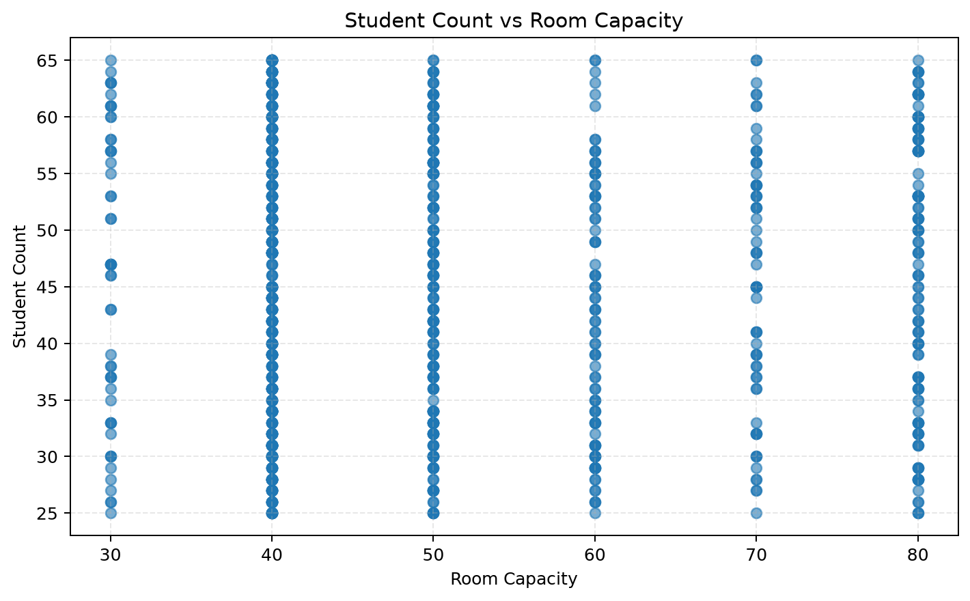
Figure 6. Student count compared with room capacity.
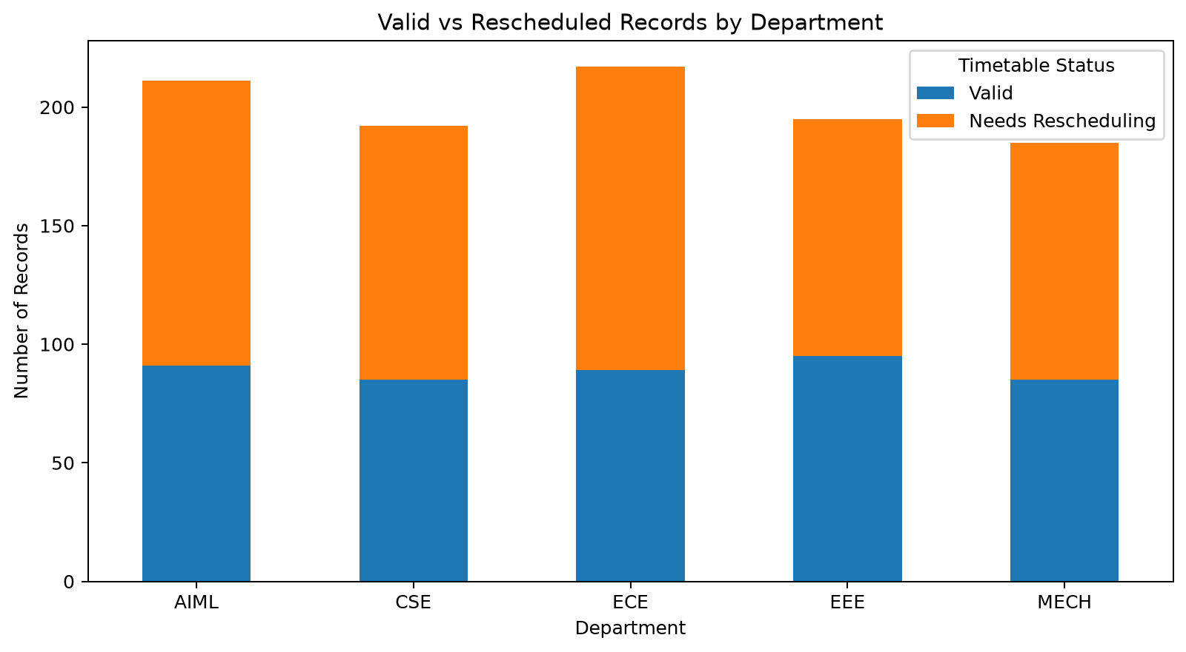
Figure 7. Timetable status by department.
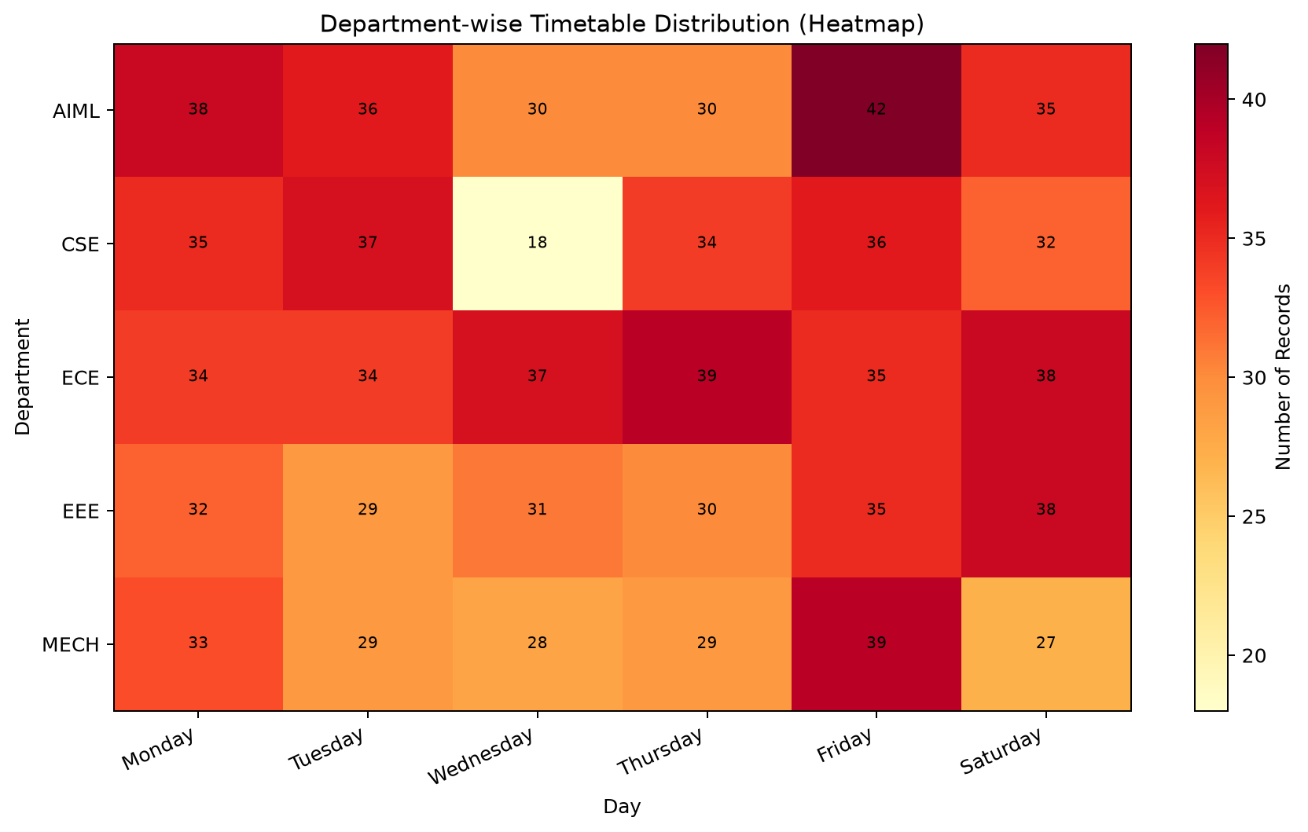
Figure 8. Department-wise timetable distribution by day.

8. How to Run the Python Workflow
Install Python 3 and the required libraries:
pip install pandas openpyxl matplotlib
Run the scripts in the project folder in this order:
python data_cleaning.py
python Data_analysis.py
python Data_visualisation.py

9. Limitations
The ZIP package contains data preparation, analysis and visualization scripts, but does not include the source code for a trained AI model or a scheduling optimization engine. The AI_Recommendation and Timetable_Status values are present as fields in the supplied dataset; the available scripts summarize these labels rather than training or validating a predictive model. The included Power BI file is provided as a dashboard artifact, but its internal pages and measures have not been independently documented in this report.

10. Future Enhancements
- Develop a constraint-based engine that generates complete schedules rather than only analyzing existing records.
- Introduce a validated conflict-detection algorithm for faculty, room, section and time overlaps.
- Evaluate suitable optimization methods or machine-learning models using train/test separation and measurable metrics.
- Build a web-based interface for administrators and department coordinators.
- Add exports to Excel/PDF, schedule revisions, alerts and user access control.
- Test the generated timetable against real institutional requirements and user feedback.

11. Conclusion
The project demonstrates a practical data workflow for timetable preparation and review. The supplied dataset was analyzed across five departments, timetable status, recommendation types, conflict indicators and student strength. Python scripts automate cleaning, summary generation and chart creation, while the Power BI file provides an additional dashboard artifact. The work is a foundation for a more complete AI-assisted timetable generation system, with automated constraint solving and model validation identified as important next steps.

12. References / Project Files
- AI_Based_Timetable_Dataset_1000_Records.xlsx — source dataset.
- data_cleaning.py — preprocessing script.
- Data_analysis.py — summary analysis script.
- Data_visualisation.py — visualization script.
- analysis_summary.txt and department_summary.csv, status_summary.csv, recommendation_summary.csv — generated outputs.
- AI Based Time Table.pbix — supplied Power BI dashboard file.
- Python, pandas, OpenPyXL and Matplotlib documentation.

